Module:1

**1.what is software?what is software engineering?**

* software is a set of instructions,data or program used to operate computers and execute specific tasks.
* It is the opposite of hardware,which describe the physical aspect of a computer.
* software is a generis term used to refer to application,scripts and program that run on a device.
* **What is software engineering?**
* Software engineering is defined as a process of analyzing user.Requirement and then desiging,building,and testing software application which will satisfy those requirement.
* Software engineering is the process of developing,testing and deploying computer applications to solve real-world problems by adhering to a set of engineering principles and best practices.

**2. Explain types of software**

* There are 5 types of

1. Application software
2. System software
3. Driver software
4. Middleware software
5. Programming software
6. **Application Software**

This software that a perform specify tasks to user needs is called a application software.

Ex. PowerPoint, Microsoft

**2. System Software**

System software is a type of computer program that is designed to run a computer hardware and application program.

Ex. Notepad

**3. Driver Software**

A device driver is a piece of software that interfaces a particular piece of hardware

Ex. Video Drive, Audio Drive

**4. Middleware Software**

Middleware describes the term software and it mediates between application.

Ex. application server middleware

**5. Programming Software**

Computer programmers use programming software to write code.

Ex. Vs code, Turbo c

**3. What is SDLC? Explain each phase of SDLC**

**SDLC:** Software Development Life Cycle

SDLC is a provides step by step guidance for building software.

1. Planning
2. Analysis
3. Design
4. Implementation
5. Testing & Integration
6. Maintenance
7. **Planning**

* Planning is done for the project by the developer.
* This phase involves defining the scope of the software project, identifying the gools, and developing a roadmap for the project.

**2. Analysis**

* In this phase, the software requirements are gathered and analysis.
* This phase helps to define the system functionalities, constraints, and specification.

**3. Design**

* In this phase, the system architecture, user interface, and the overall software design are defined the design phase include creating blueprints, diagrams and flowcharts that illustrate the system functionality.

**4. Implementation**

* In this phase the actual coding of the software takes place.
* The software developer write code based on the design specification and the software is built.

**5. Testing & Integration**

* Once the software is built, it is tested to identify and resolve any defect. Bugs, or errors.
* Testing helps to ensure the software meets the desired quality and functionality.

**6. Deployment**

* In this phase the software is released to the software is released to the production environment.
* It is installed and made available for use by the end-user.

**7. Maintenance**

* The software is monitored and maintained to ensure it is performing as expected.
* Any issues or bugs that are discovered are fixed, and update are made as needed.

**4. What is DFD? Create a DFD diagram on Flipkart**

* A data flow diagram is a pictorial model that shows the flow of data between the various subsystem or processes of a system
* The purpose of the data flow diagram is to highlight…

The functions of a system and to show how the system stores information and the how information is transferred between data stores

* **DFD diagram on Flipkart**

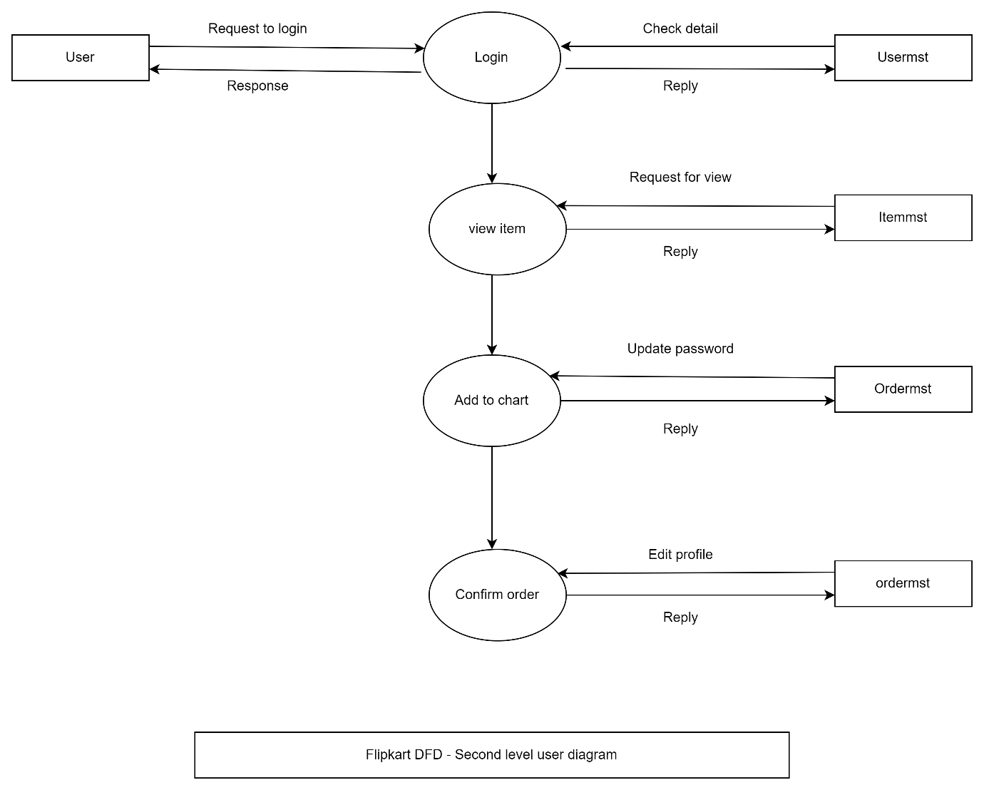

**5. What is Flow chart? Create a flowchart to make addition of two numbers**

* Flowchart is combination of two words i.e., flow and chart. Chart consist of different symbols to display information about any program. Flow indicates the direction o processing that take place inthe program. Flowchart is a graphical representation of an algorithm.
* It is a used to show all the steps of an algorithm in a sequence.
* **Flowchart to make addition of two number**

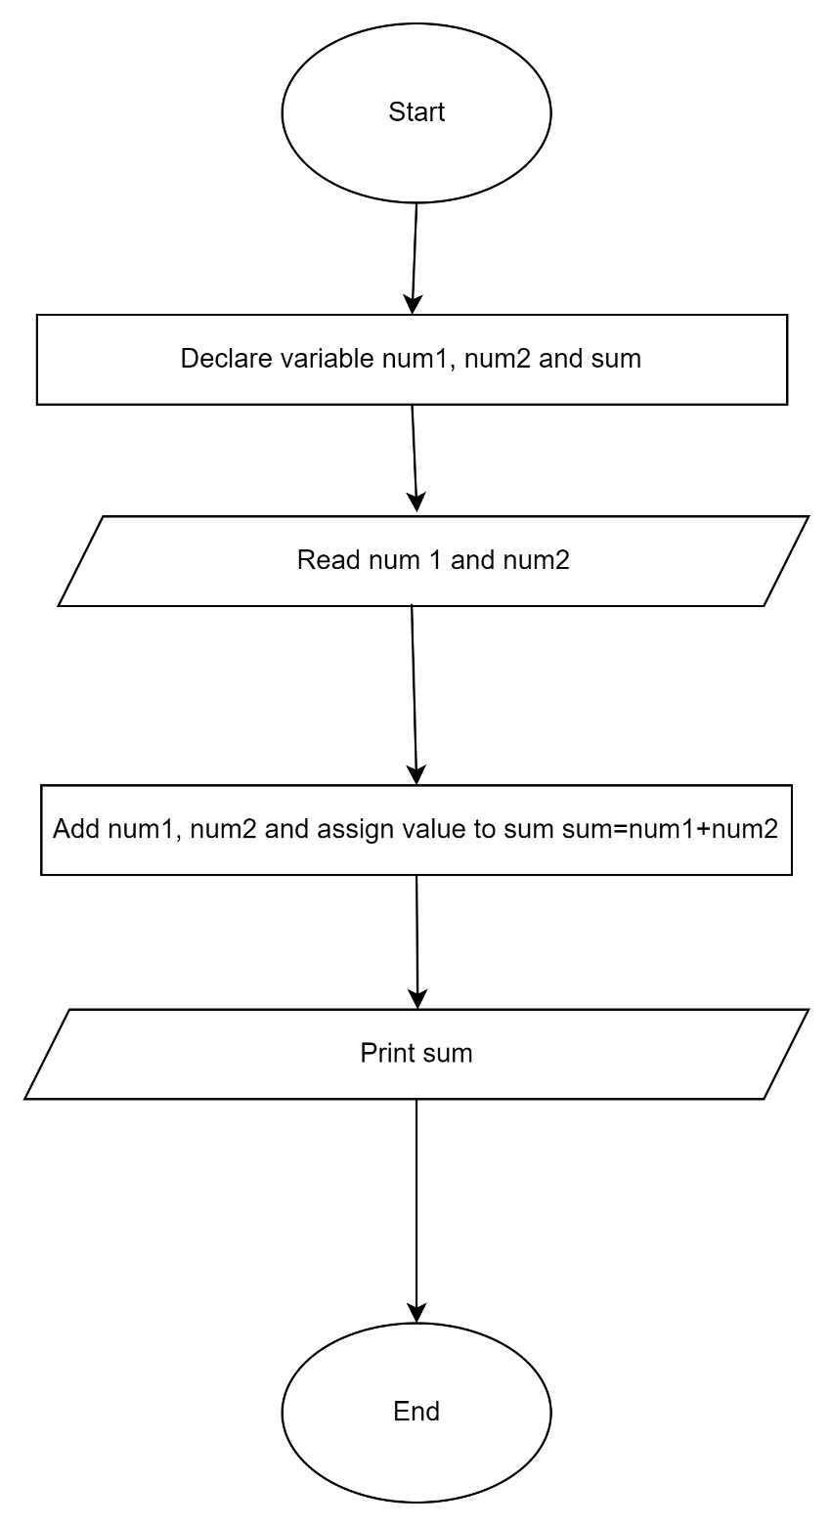

**6. What is Use case Diagram? Create a use-case on bill payment on Paytm.**

* A use case diagram is a graphical depiction of user’s possible interactions with a system. A case diagram shows various use cases and different types of users the system has and will often be accompanied by other types of diagram as well. The use cases are represented by either circles or ellipses. The actors are often shown as stick figures.
* **Create a use-case on bill payment on Paytm**

